Упражнения по формированию устно-речевых умений
школьников средней ступени в формате ОГЭ,
тема «There is no place like home»

- Reading the text aloud.
Pre-reading exercises
- Read the transcription of these words
Majority |məˈdʒɒrɪti| However |haʊˈɛvə| detached |dɪˈtatʃt| neighbouring |ˈneɪb(ə)rɪŋ|

- Pay attention to the sounds which are not typical for the Russian language. Practice reading the following sentences.
[ð] The northern weather was rather severe for them.
[w] William won the watch.
[v] The drivers arrived at eleven.
[ɜ:] The servants searched for the girl’s turtle.
repeat the sounds, read the examples, find words with these sounds in the text

- Linking [r] The car is in the garage. Find the examples in the text.
- Divide the first 3 sentences into sense fragments.

- Read the text one by one

People in the UK live in houses, flats, and cottages, but the majority of people live in houses. However, there are many different houses in the UK. Firstly, there are detached houses, which are near
the countryside and are completely independent. Then /there are semi-detached houses.// These houses
are nearer the town centre/ and are different than detached houses in that /one side of the house is connected to another one.// Finally,/ there are terraced houses.// These are houses/ which have a neighbouring house on either side.// They can be very small /with only two floors,/ or can be very large/ with up to five floors /with four or five bedrooms.

- Giving full answers to the questions

Match the parts to complete a question.
- Do you … | …your favourite place in your flat? Why?
- Is your flat … | … are there in your flat?
- How many rooms … | a TV set in the kitchen?
- What is … | … your own room?
- Have you got … | … live in a house or in a flat? Personally…, As for me
- Have you got … | … comfortable?
- Is it important … | … your parents with household chores?
- Do you help … | for a teenager to have the own room?

- Answer the following questions using introductory words.

1 вопрос – работа по цепочке.
5 вопрос – работа по цепочке (приборы)
7 вопрос – работа по таблице
8 вопрос – домашние обязанности. – переход к следующему заданию

7)  I think,  I consider,  In my opinion,  I believe,  I suppose,  To my mind, | it is very important for teenagers to have the own room because | they need personal space.
 |  | they asks for it.
 |  | they are responsible enough.
 |  | they need independence.
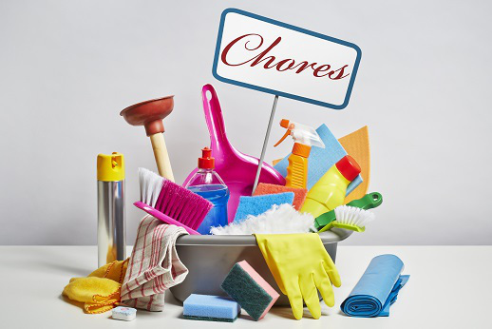
- Giving a talk .

Give a talk about household chores.

Remember to say:
- what household chores you are responsible for;
- which chores you prefer, and why;
- what your least favourite household duty is, and why.

Exercises

- Translate from Russian into English.

Домашние обязанности; заправлять кровать; поливать цветы; пылесосить; дважды в неделю; убирать всю кухню; последнее, но не менее важное; резиновые перчатки; все виды химикатов.

- Choose sentences to each point of the plan.

- I have to wear rubber gloves and use all kinds of chemicals.
- ____, I should to make my bed every morning.
- I am going to give a talk about household chores.
- Sometimes I help my mum to cook dinner in the evenings.
- ____, it is interesting to talk about it.
- I enjoy doing it, because I like cooking.
- ______, I would like to say that household chores are boring but useful.
- _____, I have to clean the whole kitchen at the weekends.
- ____, I am responsible for many household chores.
- That is all I wanted to say about it.
- _____, it is very important but I hate doing it.
- _____, I wash the flowers and do the vacuuming twice a week.
- ______, I have to clean the bathroom on Sundays.

- Add the following introductory words where necessary.

To my mind, To sum up, Actually, Firstly, Secondly, Unfortunately, Moreover, No doubt

- Let’s give a talk.

I am going to give a talk about household chores. To my mind, it is interesting to talk about it.
Actually, I am responsible for many household chores. Firstly, I should to make my bed every morning. Secondly, I wash the flowers and do the vacuuming twice a week. Moreover, I have to clean the whole kitchen at the weekends.
Sometimes I help my mum to cook dinner in the evenings. I enjoy doing it is, because I like cooking.
Unfortunately, I have to clean the bathroom on Sundays. No doubt, it is very important but I hate doing it. I have to wear rubber gloves and use all kinds of chemicals.
To sum up, I would like to say that household chores are boring but useful. That is all I wanted to say about it.

